1. **SELECT * FROM dokter**

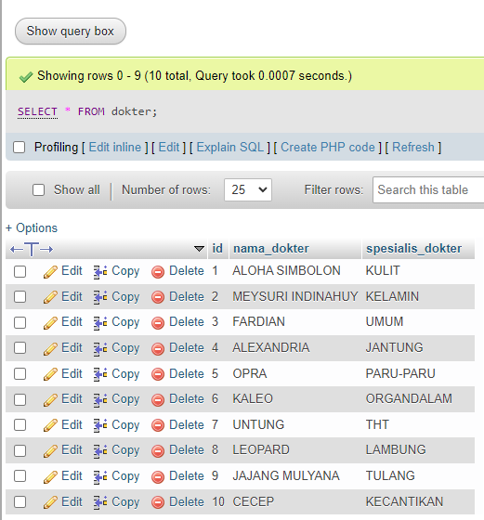

1. **SELECT * FROM obat ORDER BY nama_obat ASC**

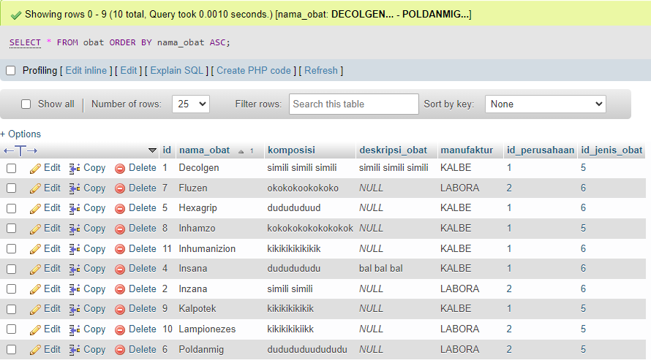

1. **SELECT * FROM obat ORDER BY nama_obat DESC**

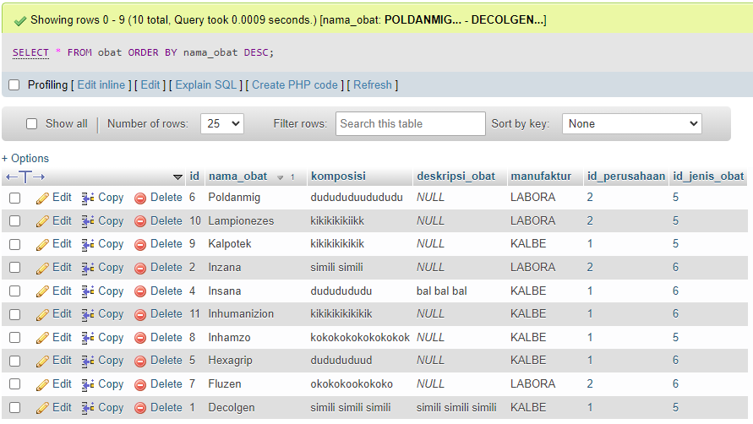

1. **SELECT nama_obat, komposisi FROM obat**

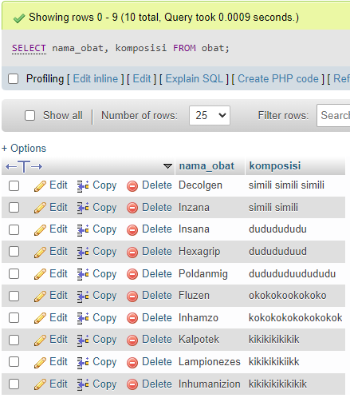

1. **SELECT * FROM pasien WHERE nama_pasien LIKE 'A%'**

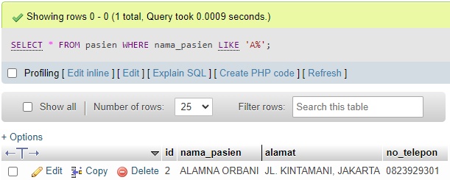

1. **SELECT id, manufaktur FROM obat WHERE nama_obat LIKE '%AN%'**

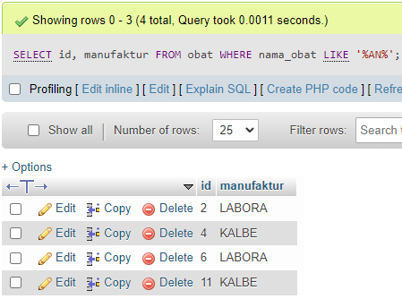

1. **SELECT id_perusahaan, COUNT(id) as total_obat FROM obat GROUP BY id_perusahaan**

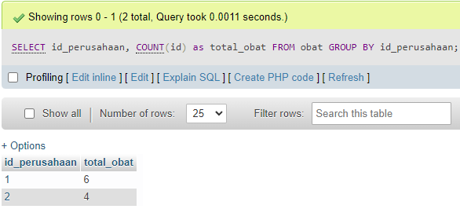

1. **SELECT id_perusahaan, SUM(id) as total_jumlah_id FROM obat GROUP BY id_perusahaan**

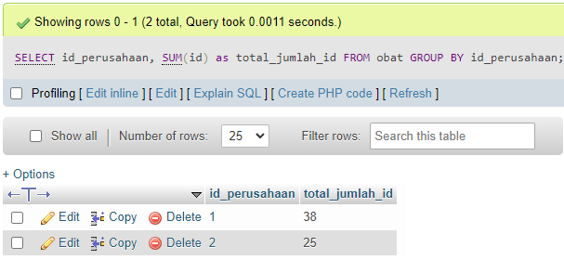

1. **SELECT * FROM transaksi WHERE tanggal_beli > '2022-02-24'**

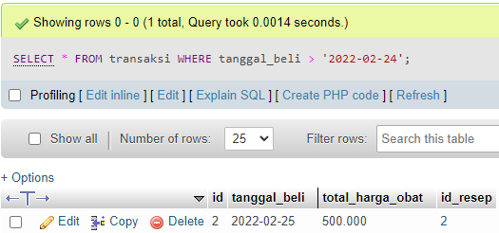

1. **SELECT * FROM transaksi WHERE total_harga_obat >= 300**

